Cluster Benchmarking Screenshots (Our Cluster) GMSC Group 1

hellohostname
Description: print the name of the host machine and the process that executed it.

Number of Processors: 1
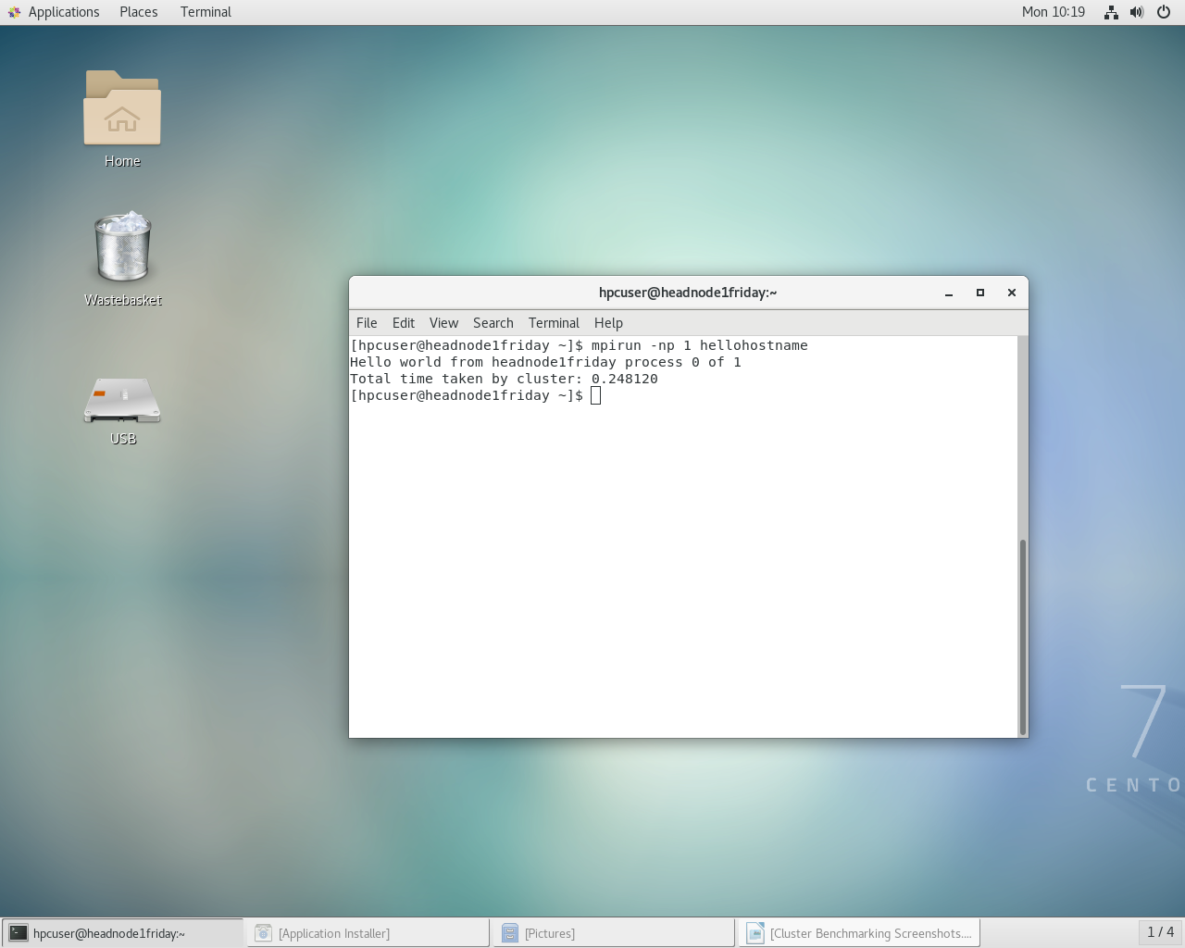

Number of Processors: 2
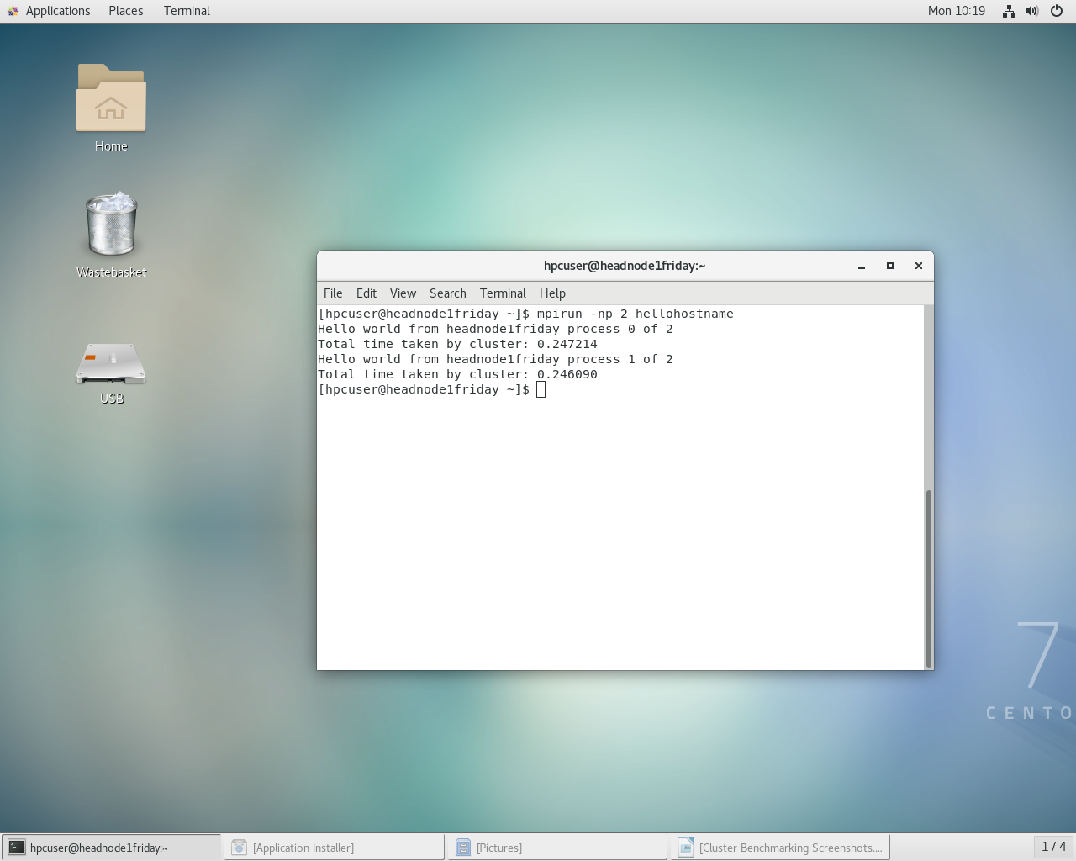

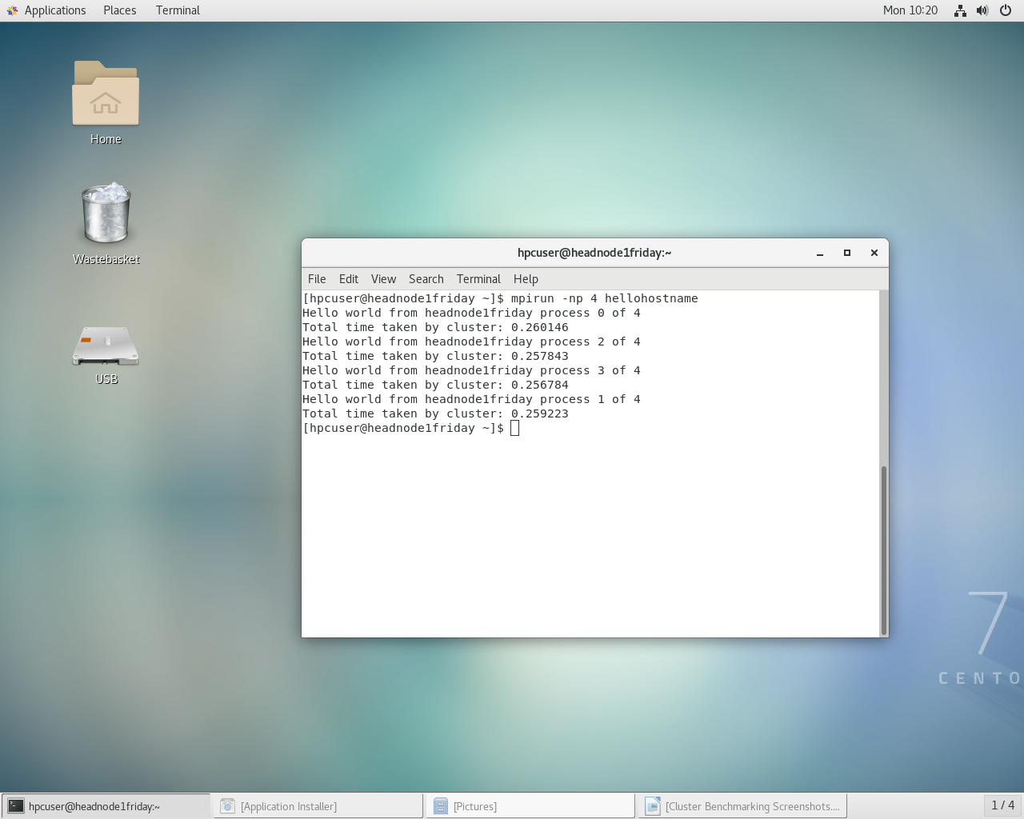
Number of Processors: 4

mat-mat
Description: perform a serial and parallel calculation across the cluster and return the result

Number of Processors: 1

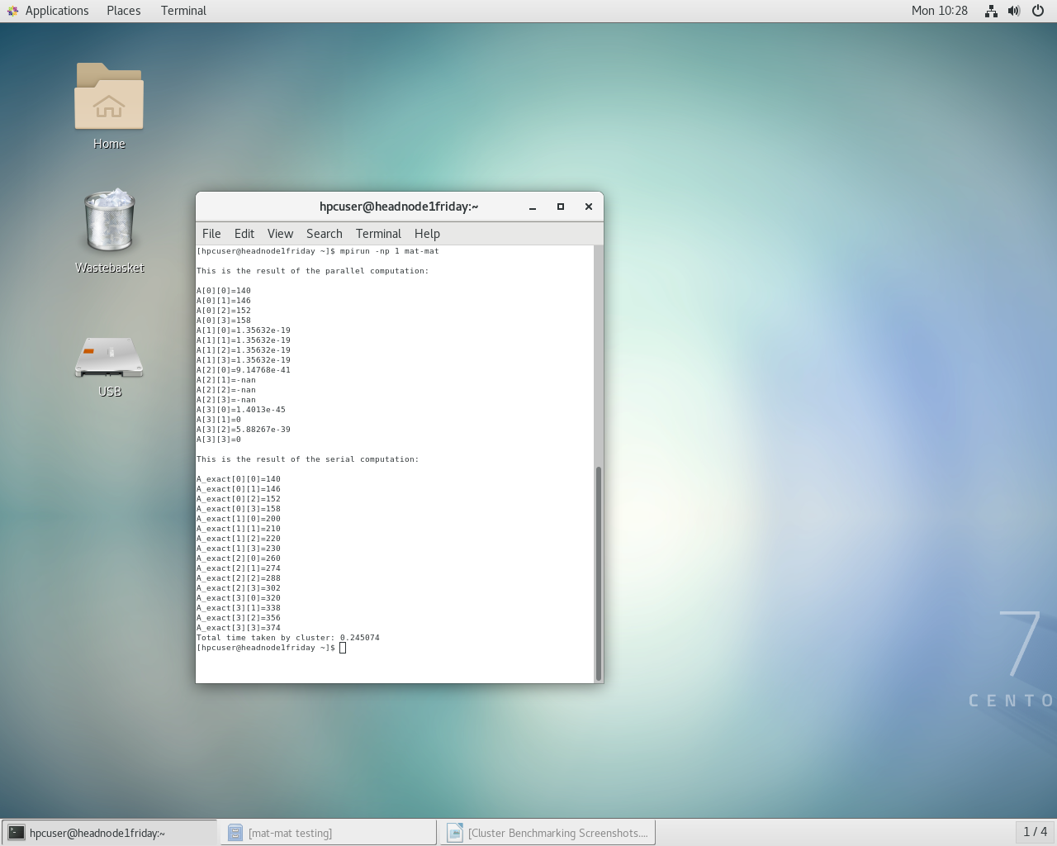

Number of Processors: 2
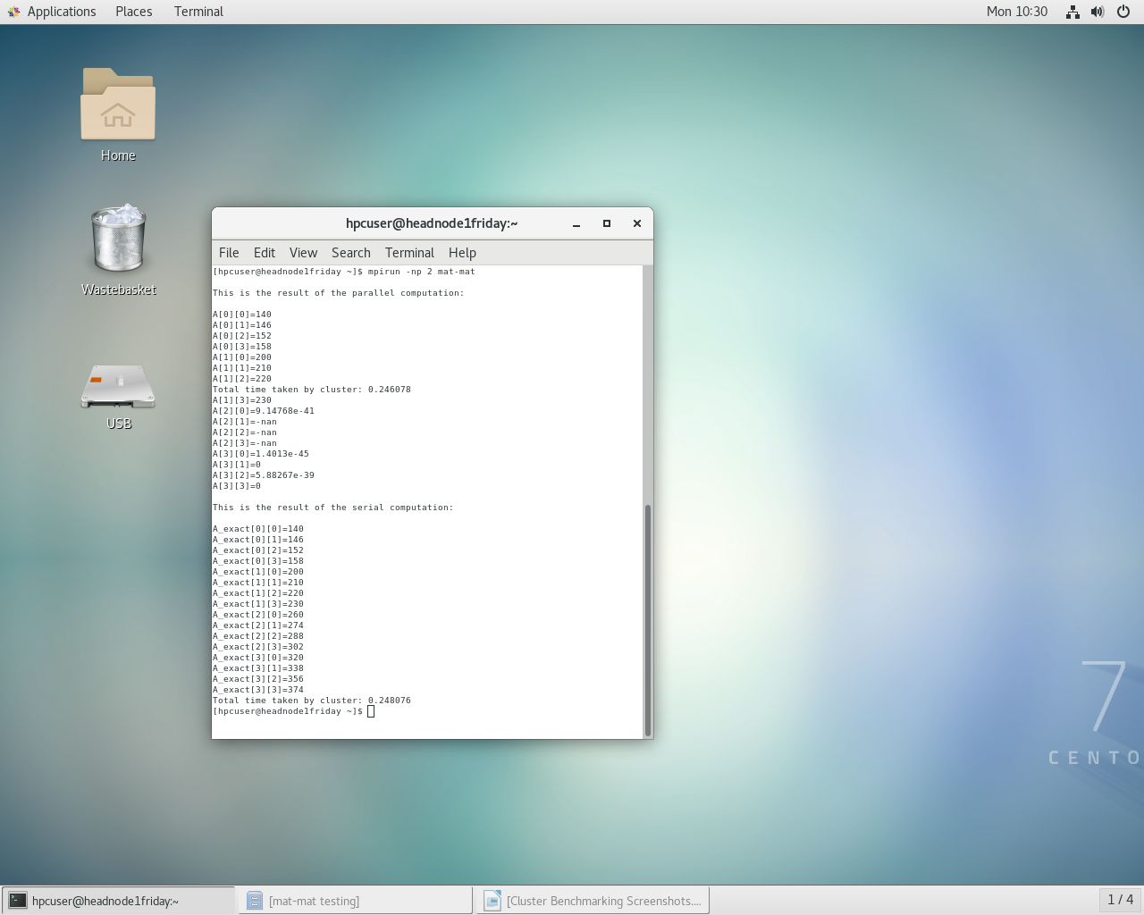

Number of Processors: 4
